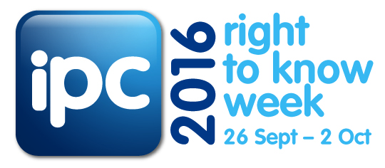
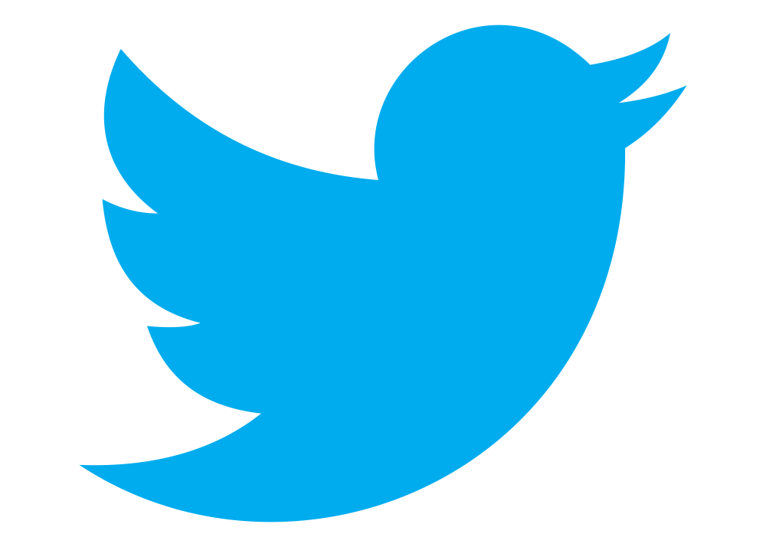SUGGESTED CHAMPION TWEETS /SOCIAL MEDIA STATUS UPDATES RIGHT TO KNOW WEEK 2016
Tweet or update your organisation’s social media status as often as you like in the lead up to and during Right to Know Week (26 September – 2 October 2016). You are welcome to craft your own messages.
TIPS!
- Use the official Right to Know hash tag #RTK2016. Consider using the hash tag #opengov to increase the reach of your organisation’s tweets/social media activity
- Text highlighted yellow indicates a link you will need to insert or generate before tweeting/posting
- If your organisation permits, use Bitly to shorten links
- The IPC will also be posting on Twitter, so please re-tweet any of our messages throughout the week.
Our Twitter handle is: @IPCNSW
- Follow any relevant policies or guidelines issued by your organisation.

Here are some suggestions to get you started:
In the lead up to Right to Know Week
1 | We are getting ready for Right to Know Week in NSW 26 Sept – 2 Oct 2016 #RTK2016 #IPCNSW #opengov
2 | Did you know you can access government held information? For more information visit: (insert link to IPC website or your organisation's GIPA page) #RTK2016 #opengov
3 | We are proud to be one of IPC's Right to Know Week 2016 Champions. #RTK2016 showing our commitment to #opengov (link to IPC's RTK webpage: http://ipc.nsw.gov.au/news-media/events/right-know-week-2016) or your event listing
Start of Right to Know Week
4 | 26 September 2016 | We are a proud Champion of #IPCNSW Right to Know campaign (suggest link to your website RTK related news item/carousel/media release) #RTK2016 #opengov
Throughout Right To Know Week
5 | We are championing your right to know in NSW #RTK2016 #opengov You have a Right to Know!
6 | You can access information held by NSW government. Do you know your rights? Find out more at (insert link to IPC website or your organisation's GIPA page) #RTK2016 #opengov
7 | #RTK2016 Open Government in Action promoting accessible gov responding to your needs (link to ipc website http://ipc.nsw.gov.au/news-media/events/right-know-week-2016) #opengov

